1:启动画面

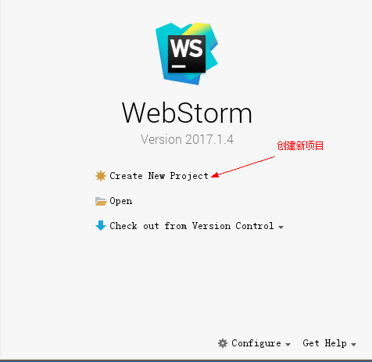

2：选择项目运行目录

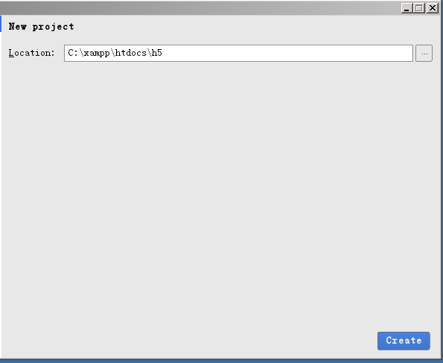

3:设置

1. 项目编码

(gb2312/utf-8/gbk/ANSI…)

File->Settings->Editor->File Encodings->

Global Encoding [UTF-8]

Project Encoding[UTF-8]

{Apply}

1. Javascript 编译标准 ES-6

File->Settings->Language->JavaScript

1. 服务器 apache

File->Settings->Build,Execution

Depolyment->

(4)字体大小